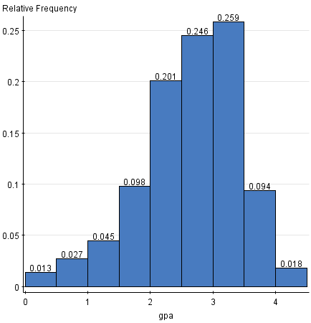

* 1. The shape of histogram is of a bell curve, skewed left. The data is largely concentrated from the gpa values of 2 – 3.5.
  2. The variable gpa has a small variance and standard deviation. Because the values are close to 0, this means that there isn’t a very large spread of data, and that a large concentration of the data points fall close to the mean of 2.635.

**Summary statistics:**

|  |  |  |  |
| --- | --- | --- | --- |
| **Column** | **Mean** | **Variance** | **Std. Dev.** |
| gpa | 2.6352232 | 0.60745645 | 0.7793949 |

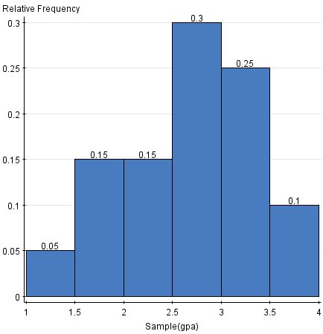

**Summary statistics:**

|  |  |
| --- | --- |
| **Column** | **Mean** |
| Sample(gpa) | 2.656 |

* 1. It does a very good job of estimating the population mean; the means are nearly identical, and when rounded to two decimal places, there is only a .03 difference between the statistical mean and the mean of the entire population.

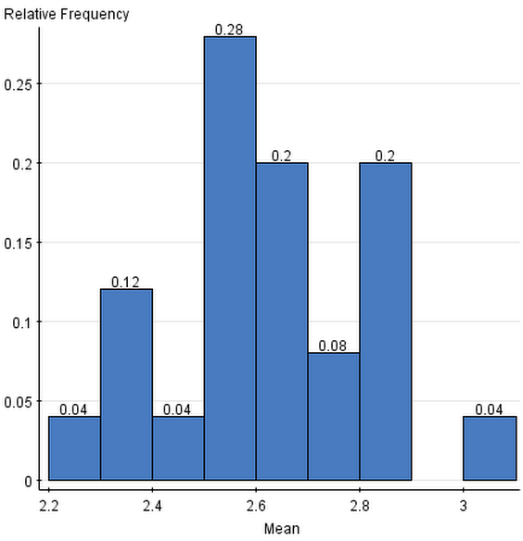

* 1. The shape of the graph is strange. Though the data still seems to be concentrated around 2.6, the shape does not appear to be that of a bell curve and it is hard to classify it as either unimodal or bimodal. Its center seems to be somewhere around 2.6, and the data has a slightly higher spread of data to the right of the mean; over 40% of the data lies above the mean.

**Summary statistics:**

|  |  |  |  |
| --- | --- | --- | --- |
| **Column** | **Mean** | **Variance** | **Std. Dev.** |
| Mean | 2.62866 | 0.03513468 | 0.18744248 |

* 1. Yes, there is low bias. Rounded to two decimal places, the means are essentially identical. The values of 2.64 and 2.63 only differ by .01.
  2. 0.60745645/20 = 0.0303728225. The variance is almost identical to the one above. 0.03037282251/2 = 0.1742780034. This is nearly identical to the standard deviation above, with a difference of only around .01.

**Part II: Probability**

* 1. S = {Spades: 2, 3, 4, 5, 6, 7, 8, 9 , 10, ace, jack, queen, king,  
     Clubs:  2, 3, 4, 5, 6, 7, 8, 9, 10, ace, jack, queen, king,  
     Diamonds:  2, 3, 4, 5, 6, 7, 8, 9, 10, ace, jack, queen, king,  
     Hearts:  2, 3, 4, 5, 6, 7, 8, 9, 10, ace, jack, queen, king}
  2. 1/52
  3. 13/52 or 1/4
  4. 4/52 or 1/13

1. 0.122 for rolling a 1, 0.167 for rolling a 2, 3, 4, or 5, and 0.21 for rolling a 6.

Because: 1/6 = 0.167

0.167 * 4 = 0.668 of rolling a 2, 3, 4, or 5 (total)

1 – 0.668 = 0.332

1 - .21 = 1.22 for rolling a 1.

This makes sense, since the probability of rolling a 1 should be less than the probability of rolling any of the other values.